**IT3280E Computer Architecture Lab**

**Nguyễn Đức Anh**

**MSSV: 20235890**

**Lab 4: Arithmetic and Logical Instruction**

**Assignment 1:**

Case 1: both s1 and s2 are positive.

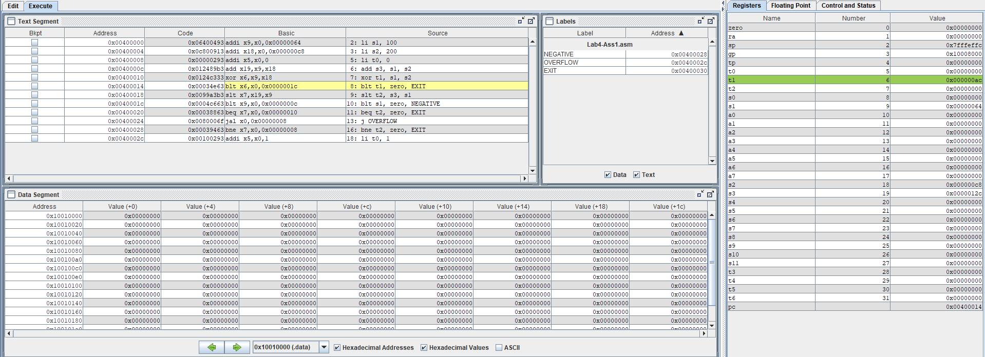

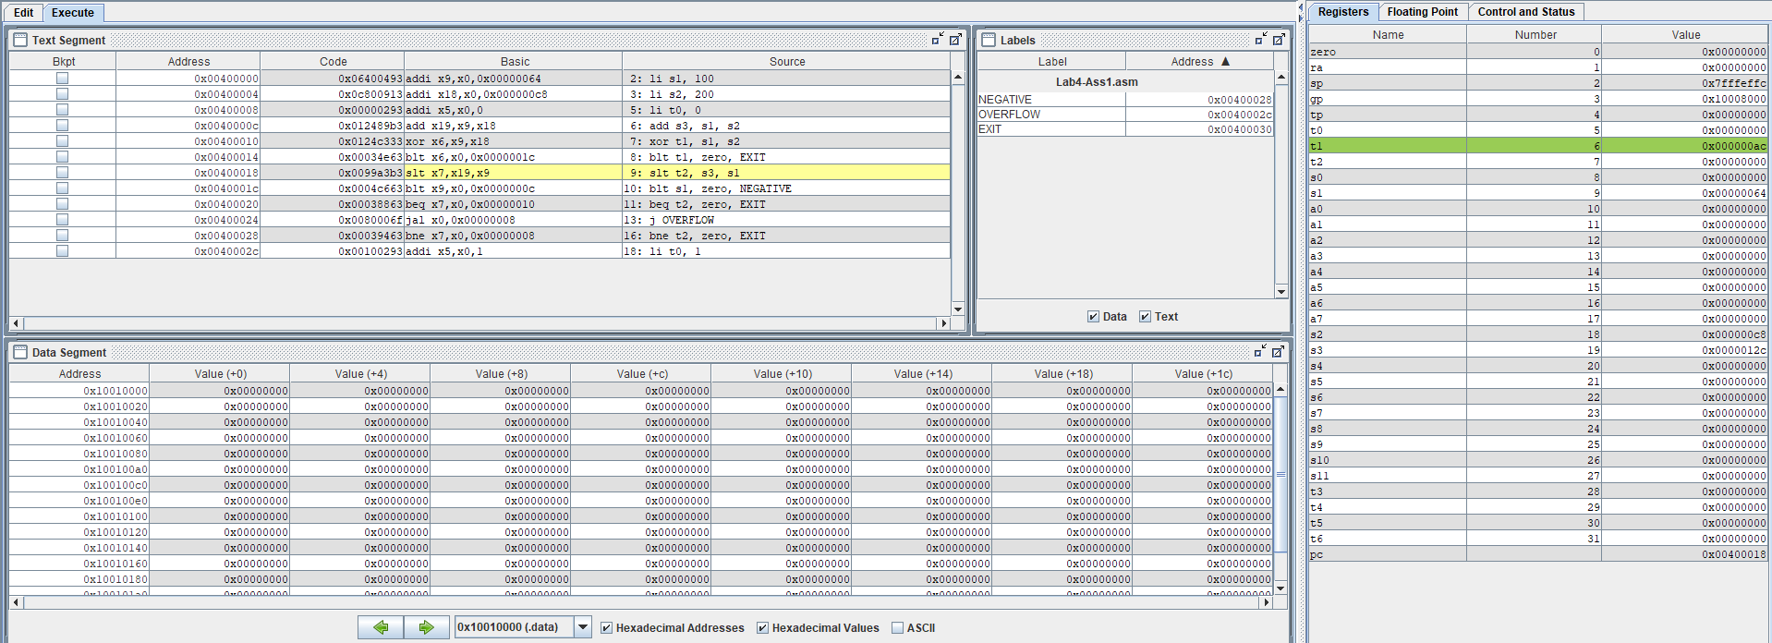

Case 2: both s1 and s2 are negative.

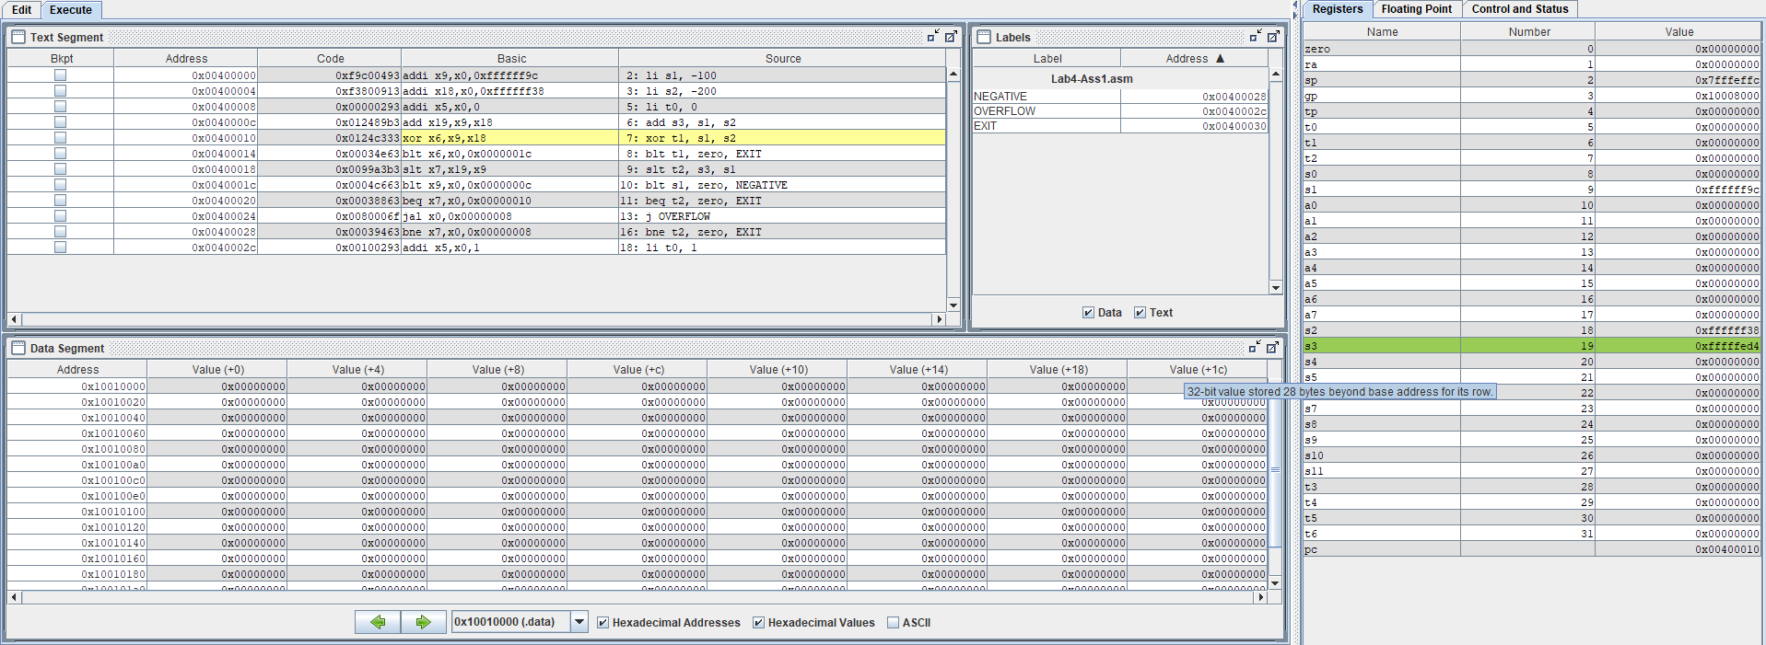

Case 3: s1 assign to max 32bit value, and s2 = 1.

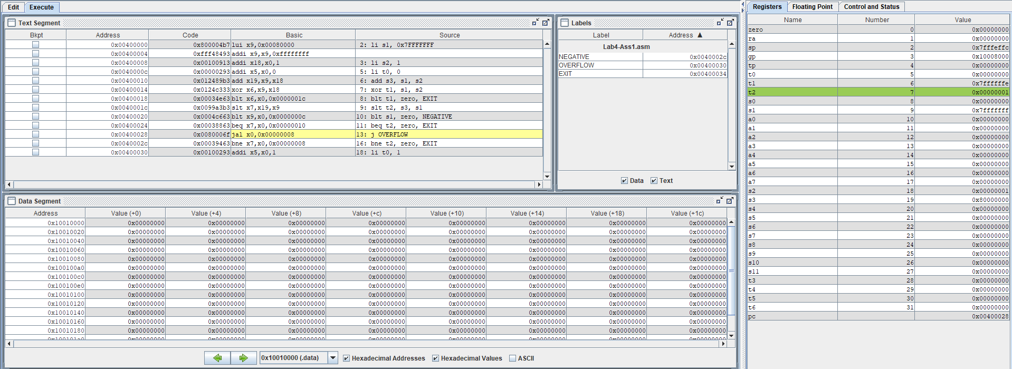

**Assginment 2:**

**Assignment 3:**

A,

B,

C,

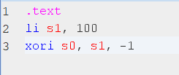

D,

**Assignment 4:**

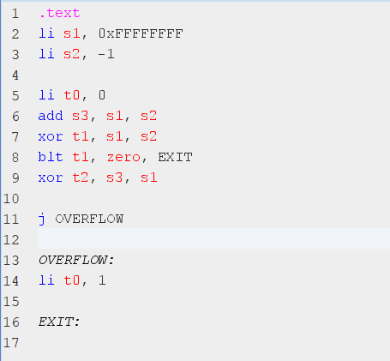

**Assignment 5:**

